Metalworking is the process of shaping and reshaping metals to create useful objects, parts, assemblies, and large scale structures.
Modern metalworking processes, though diverse and specialized, can be categorized into one of three broad areas known as forming, cutting, or joining processes.

Cutting processes
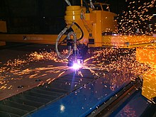
A CNC plasma cutting machine.
Cutting is a collection of processes wherein material is brought to a specified geometry by removing excess material using various kinds of tooling to leave a finished part that meets specifications. The net result of cutting is two products, the waste or excess material, and the finished part. In woodworking, the waste would be sawdust and excess wood. In cutting metals the waste is chips or swarf and excess metal.
Drilling a hole in a metal part is the most common example of a chip producing process. Using an oxy-fuel cutting torch to separate a plate of steel into smaller pieces is an example of burning. Chemical milling is an example of a specialty process that removes excess material by the use of chemicals.
There are many technologies available to cut metal, including:
- Manual technologies: saw, chisel, shear or snips
- Machine technologies: turning, milling, drilling, grinding, sawing
- Welding/burning technologies: burning by laser, oxy-fuel burning, and plasma
- Erosion technologies: by water jet, electric discharge, or abrasive flow machining.
- Chemical technologies: Photochemical machining
Cutting fluid or coolant is used where there is significant friction and heat at the cutting interface between a cutter such as a drill or an end mill and the workpiece. Coolant is generally introduced by a spray across the face of the tool and workpiece to decrease friction and temperature at the cutting tool/workpiece interface to prevent excessive tool wear. In practice there are many methods of delivering coolant.

Milling
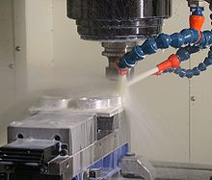
A milling machine in operation, including coolant hoses.
Milling is the complex shaping of metal or other materials by removing material to form the final shape. It is generally done on a milling machine, a power-driven machine that in its basic form consists of a milling cutter that rotates about the spindle axis (like a drill), and a worktable that can move in multiple directions (usually two dimensions [x and y axis] relative to the workpiece). The spindle usually moves in the z axis. It is possible to raise the table (where the workpiece rests). Milling machines may be operated manually or under computer numerical control (CNC).Safety is key with these machines. The bits are traveling at high speeds and removing pieces of usually scalding hot metal. The advantage of having a CNC milling machine is that it protects the machine operator.

Turning
Turning is a metal cutting process for producing a cylindrical surface with a single point tool. The workpiece is rotated on a spindle and the cutting tool is fed into it radially, axially or both.
A lathe is a machine tool which spins a block or cylinder of material so that when abrasive, cutting, or deformation tools are applied to the workpiece, it can be shaped to produce an object which has rotational symmetry about an axis of rotation.
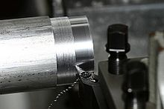
A lathe cutting material from a workpiece.
Turning is a metal cutting process for producing a cylindrical surface with a single point tool. The workpiece is rotated on a spindle and the cutting tool is fed into it radially, axially or both.
A lathe is a machine tool which spins a block or cylinder of material so that when abrasive, cutting, or deformation tools are applied to the workpiece, it can be shaped to produce an object which has rotational symmetry about an axis of rotation.

Grinding
A surface grinder
Grinding uses an abrasive process to remove material from the workpiece. A grinding machine is a machine tool used for producing very fine finishes, making very light cuts, or high precision forms using an abrasive wheel as the cutting device. This wheel can be made up of various sizes and types of stones, diamonds or inorganic materials.
Grinders have increased in size and complexity with advances in time and technology.
Grinders need to be very rigid machines to produce the required finish. In the past grinders were used for finishing operations only because of limitations of tooling.

Filing
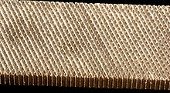
A file is an abrasive surface like this one that allows machinists to remove small, imprecise amounts of metal.
Filing is combination of grinding and saw tooth cutting using a file. Prior to the development of modern machining equipment it provided a relatively accurate means for the production of small parts, especially those with flat surfaces. Files can vary in shape, coarseness, and whether the teeth or single cut or double cut depending on what application the file is to be used for.

